As Agents of S.I.S. CUBACONTROL S.A.

F095103 416764ANO.10-05-01 CCA / MC

CERTIFICATE OF INSPECTION

In pursuance to an order received from:

Messrs. S.I.S. CUBACONTROL S.A., on Seller’s account

to carry out instructions summarized as:

Quantity, Weight, Packing, Marking & Loading supervision.

of a consignment described as follows:

Ref.: CMI 2109-1583
Seller: UNITED PRODUCTS LTD
Buyer: EINARBO, S.A
Address: Calle Churruca No. 481 e/ Vía Blanca y Washington.
Cerro, La Habana, Cuba
Contract: EBSA-21-1-06
Product: Aditivos para la producción de Aceite Supermultigrado
Quantity: 2 x 20’ Containers

This is to certify that upon instructions received our inspectors have supervised a parcel described as:

Aditivos para la producción de Aceite Supermultigrado
(CORA SUPER)

Place of supervision: Casalnuovo (NA)
Date of supervision: 5th November 2021

Quantity :
Total quantity of packages, as ascertained by our inspector : n. 40

Stowage details - 20‘ Containers:
Container List | Item declared as | Number of packages
TEMU 390348/5 | Pallets | 20
GESU 115444/8 | Pallets | 20
 | Total number of packages | 40

Packing:
Pallets.
Based on a visual inspection on external packages, the goods have been properly packed.

Marking:

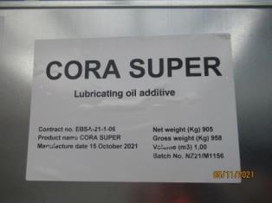

Weight:
Check weighing was carried out under our supervision on about 10% of the tanks, selected at random by us, ascertaining :

 | TEMU 390348/5
nr | product | lot | Date prod | gross weight | tara | net
1 | CORA SUPER | NZ21/M1156 | 15.10.2021 | 961,5 | 53,5 | 908
2 | CORA SUPER | NZ21/M1156 | 15.10.2021 | 962,5 | 53,5 | 909
 | GESU 115444/8
nr | product | lot | Date prod | gross weight | tara | net
1 | CORA SUPER | NZ21/M1156 | 15.10.2021 | 962,5 | 53,5 | 909
2 | CORA SUPER | NZ21/M1156 | 15.10.2021 | 963,5 | 53,5 | 910
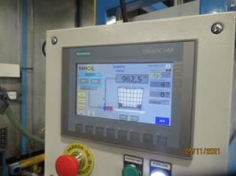
Calibration report n. 210402 dated 12.03.21

Weight:
Check weighing was carried out under our supervision on the 6 containers empty and loaded ascertaining the following weights:

Container List | Weight of the empty container kgs | Weight of the loaded container kgs | Gross weight of the goods loaded kgs
TEMU 390348/5 | 15460 | 34600 | 19140
GESU 115444/8 | 15820 | 34960 | 19140
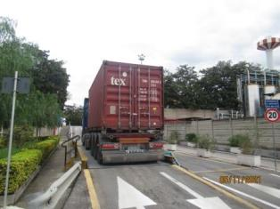
Calibration report n. 210400 dated 12.03.21

Loading :
Goods stuffed under our supervision into listed containers which, based on a visual inspection, were found in condition to receive the cargo. At the end of loading operations the following seals were affixed:

Container list | Company Seal | SGS Seal
TEMU 390348/5 | HLD0450585 | 3110402
GESU 115444/8 | HLD0450686 | 3110965

A sticker sealing the junction of both parts of the doors was put and following pictures have been taken during our intervention:

TEMU 390348/5
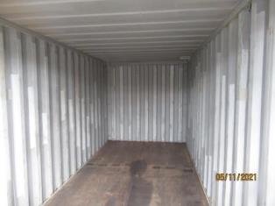 | 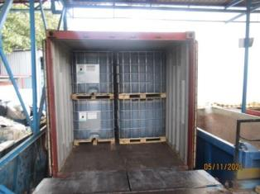 | 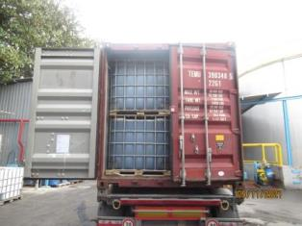
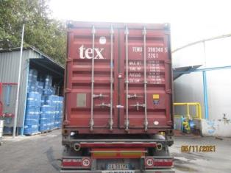 | 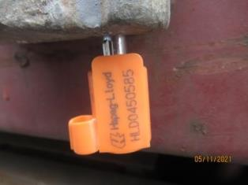 | 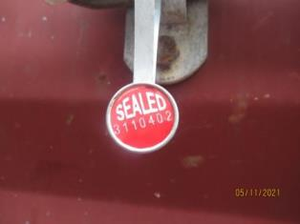
GESU 115444/8
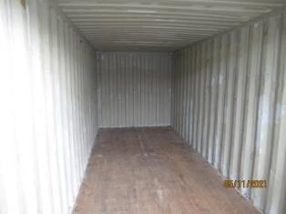 |  | 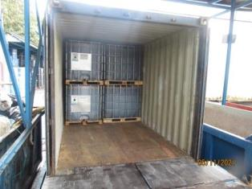 |  | 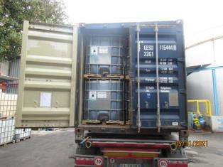
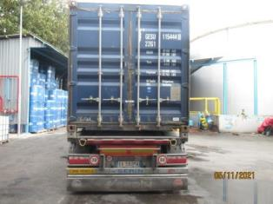 |  | 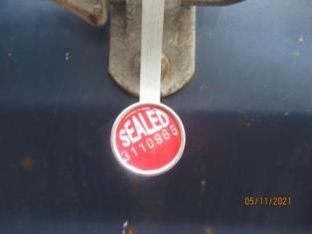 |  | 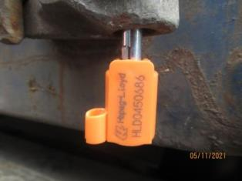

*********
This certificate reflects our findings at time and place of our intervention only and does not relieve the parties from their contractual responsibilities.

Any holder of this document is advised that the information contained hereon is limited to visual examination of the safely and readily accessible portions of the consignment only.

Signed and dated in Ravenna For and on behalf of
On 9th November 2021 SGS Italia S.p.A.

