Hai Phong City, Date: 02 November 2021

CERTIFICATE OF QUANTITY REF. NO.: 262778
A consignment designated as:
BY: VIETNAM ENGINE AND AGRICULTURAL MACHINERY CORPORATION (VEAM)
PLACE OF INSPECTION: HAI PHONG PORT, VIETNAM
DATE OF INSPECTION: ON 01 NOVEMBER 2021
SCOPE OF SERVICE: QUANTITY & WEIGHT
The consignment declared by the consignee belonging to the following shipment:
SHIPPER: DAYE SPECIAL STEEL CO.,LTD.
NOTIFY PARTY: VIETNAM ENGINE AND AGRICULTURAL MACHINERY CORPORATION (VEAM)
COMMODITY DECLARED: HOT ROLLED ALLOY STEEL ROUND BARS
QUANTITY AS PER B/L: 44 BUNDLES/ 121.688 MT
PORT OF LOADING: SHANGHAI PORT, CHINA
PORT OF DISCHARGE: HAIPHONG PORT OF VIETNAM
VESSEL: SEA WISE V.V2802
B/L NO.: 2802SH112/129 DATED: 2021.09.28
This is to report that, in compliance with the instructions received from our principal, VIETNAM ENGINE AND AGRICULTURAL MACHINERY CORPORATION (VEAM), we attended at Hai Phong Port in Hai Phong city, Viet Nam with the purpose of carrying out survey of quantity and weight of the above mentioned commodity. At time of our intervention, the cargo was loaded onto trucks from the open yard of Hai Phong Port. We hereby report our finding as follows:
PACKING: The cargo was packed in bundles. Each bundle was tied up with steel wire rods.
MARKING: As per below photos:
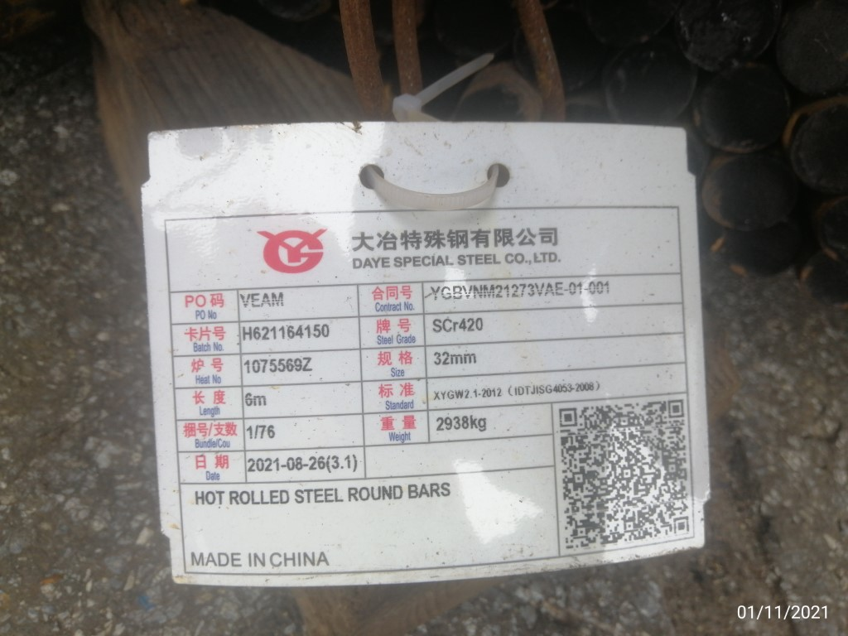 | 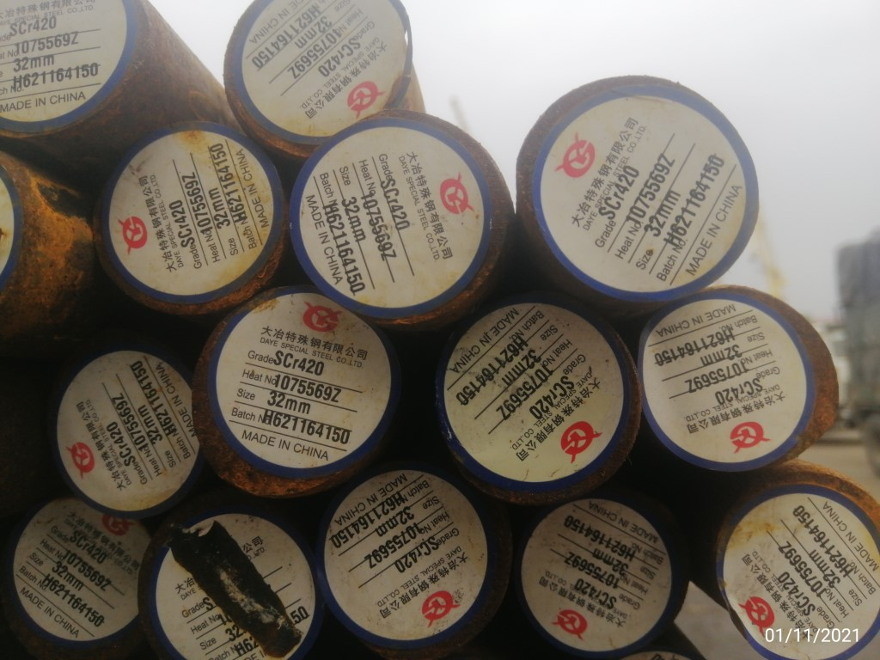 | 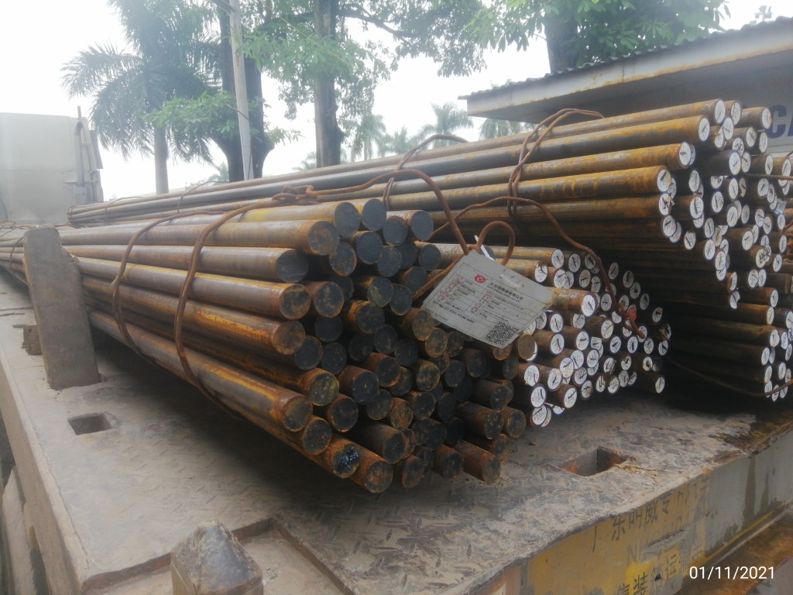

QUANTITY AND WEIGHT: Assessed by counting number of bundles and pieces during loading onto trucks at Hai Phong port. We reported the weight of cargo lot by supervision of weighing 100% of empty and full loaded trucks Hai Phong port by the bridge scales which were duly tested for accuracy by us before and during weighing. The following result was found:

1. Quantity
Nominal size  as per mark (mm) | Quantity as survey |  | Quantity as P/L |  | Difference  (Pieces)
Nominal size  as per mark (mm) | Bundles | Pieces | Bundles | Pieces | Difference  (Pieces)
Ø 32 x 6000 | 44 | 3,155 | 44 | 3,155 | Nil
2. Weight
Nominal size  as per mark (mm) | Weight (t)
Nominal size  as per mark (mm) | As survey | As P/L | Difference
Ø 32 x 6000 | 121.840 (*) | 121.688 | (+) 0.152
Remark: (*) The weight is including cargo & steel wire rods
Detail of the scales:
Bridge scale No.: 3456006 Date of calibration: 05/10/2021
Place of calibration: SMQ Haiphong Next calibration: 31/10/2022

Bridge scale No.: 3318814 Date of calibration: 30/06/2021
Place of calibration: SMQ Haiphong Next calibration: 30/06/2022

SGS VIETNAM LTD.
Tran Thi Thu Trang

